# Bansilal Ramnath Agarwal Charitable Trust’s

Vishwakarma Institute of Technology, Pune -37

*(An autonomous Institute of Savitribai Phule Pune University)*

**

**Department of Artificial intelligence and Data Science**

|  |  |
| --- | --- |
| **Division** | A |
| **Batch** | 3 |
| **Roll no** | 68 |
| **PRN no** | 12320041 |
| **Name** | Heramb Sachin Bhoodhar |
| **Subject** | WT |

**Assignment 5. Design and develop a web page to demonstrate the use of jQuery**

**Code :**

**index.html**

<!DOCTYPE html>

<html lang="en">

<head>

<meta charset="UTF-8" />

<meta name="viewport" content="width=device-width, initial-scale=1.0" />

<title>A TodoList App</title>

<link rel="stylesheet" href="style.css" />

<link

href="https://cdn.jsdelivr.net/npm/bootstrap@5.3.3/dist/css/bootstrap.min.css"

rel="stylesheet"

integrity="sha384-QWTKZyjpPEjISv5WaRU9OFeRpok6YctnYmDr5pNlyT2bRjXh0JMhjY6hW+ALEwIH"

crossorigin="anonymous"

/>

<script src="https://ajax.googleapis.com/ajax/libs/jquery/3.7.1/jquery.min.js"></script>

</head>

<body>

<section>

<div class="container" style="text-align: center; margin-top: 1.5rem">

<h1>A Todo List App <span class="badge badge-secondary"></span></h1>

</div>

<hr />

<div class="container col-xxl-8 px-4 py-2">

<div class="row flex-lg-row-reverse align-items-center g-5 py-5">

<div class="col-10 col-sm-8 col-lg-6">

<img

src="./images/img1.jpg"

class="d-block mx-lg-auto img-fluid"

alt="Bootstrap Themes"

width="700"

height="500"

loading="lazy"

/>

</div>

<div class="col-lg-6">

<h1 class="display-5 fw-bold text-body-emphasis lh-1 mb-3">

A Todo List App to Manage You Day

</h1>

<link

rel="apple-touch-icon"

sizes="180x180"

href="/apple-touch-icon.png"

/>

<p class="lead">

Efficiently manage tasks with our to-do list app. Prioritize and

organize with ease. Stay productive and focused. Customize your

lists effortlessly. Experience seamless task management.

</p>

<div class="d-grid gap-2 d-md-flex justify-content-md-start">

<a href="#scroll">

<button

type="button"

class="btn btn-primary btn-lg px-4 me-md-2"

>

Get Started

</button>

</a>

</div>

</div>

</div>

</div>

</section>

<section>

<div class="container">

<div class="title">

<h2 id="#scroll">Add to Task List</h2>

</div>

<div class="in_but">

<input

id="input1"

type="text"

placeholder="Enter the task that you want to do Today"

/>

<button id="btn1" type="button" class="btn btn-primary">

Add to List

</button>

</div>

</div>

<div class="container container3" style="padding: 10px">

<div class="title">

<h2>To Do List</h2>

</div>

</div>

</section>

<section style="display: block; margin-top: 20rem">

<hr />

<footer

style="

display: flex;

justify-content: space-evenly;

align-items: center;

"

>

<div class="logo" style="justify-items: flex-start">

<img

src="./images/logoPortfolio.png"

height="80px"

width="80px"

alt=""

/>

</div>

<p>Made with ❤️ by Heramb Bhoodhar 2024</p>

<div style="display: flex; justify-content: space-around">

<a href="https://twitter.com/Heramb120" target="_blank">

<svg

xmlns="http://www.w3.org/2000/svg"

style="margin: 0px 10px"

height="20px"

width="20px"

viewBox="0 0 512 512"

>

<!--!Font Awesome Free 6.5.1 by @fontawesome - https://fontawesome.com License - https://fontawesome.com/license/free Copyright 2024 Fonticons, Inc.-->

<path

d="M389.2 48h70.6L305.6 224.2 487 464H345L233.7 318.6 106.5 464H35.8L200.7 275.5 26.8 48H172.4L272.9 180.9 389.2 48zM364.4 421.8h39.1L151.1 88h-42L364.4 421.8z"

/>

</svg>

</a>

<a

href="https://www.linkedin.com/in/heramb-bhoodhar-a09a22225/?originalSubdomain=in"

target="_blank"

>

<svg

xmlns="http://www.w3.org/2000/svg"

style="margin: 0px 10px"

height="20px"

width="20px"

viewBox="0 0 448 512"

>

<!--!Font Awesome Free 6.5.1 by @fontawesome - https://fontawesome.com License - https://fontawesome.com/license/free Copyright 2024 Fonticons, Inc.-->

<path

d="M416 32H31.9C14.3 32 0 46.5 0 64.3v383.4C0 465.5 14.3 480 31.9 480H416c17.6 0 32-14.5 32-32.3V64.3c0-17.8-14.4-32.3-32-32.3zM135.4 416H69V202.2h66.5V416zm-33.2-243c-21.3 0-38.5-17.3-38.5-38.5S80.9 96 102.2 96c21.2 0 38.5 17.3 38.5 38.5 0 21.3-17.2 38.5-38.5 38.5zm282.1 243h-66.4V312c0-24.8-.5-56.7-34.5-56.7-34.6 0-39.9 27-39.9 54.9V416h-66.4V202.2h63.7v29.2h.9c8.9-16.8 30.6-34.5 62.9-34.5 67.2 0 79.7 44.3 79.7 101.9V416z"

/>

</svg>

</a>

<a

href="https://github.com/Heramb4270?tab=repositories"

target="_blank"

>

<svg

xmlns="http://www.w3.org/2000/svg"

style="margin: 0px 10px"

height="20px"

width="20px"

viewBox="0 0 496 512"

>

<!--!Font Awesome Free 6.5.1 by @fontawesome - https://fontawesome.com License - https://fontawesome.com/license/free Copyright 2024 Fonticons, Inc.-->

<path

d="M165.9 397.4c0 2-2.3 3.6-5.2 3.6-3.3 .3-5.6-1.3-5.6-3.6 0-2 2.3-3.6 5.2-3.6 3-.3 5.6 1.3 5.6 3.6zm-31.1-4.5c-.7 2 1.3 4.3 4.3 4.9 2.6 1 5.6 0 6.2-2s-1.3-4.3-4.3-5.2c-2.6-.7-5.5 .3-6.2 2.3zm44.2-1.7c-2.9 .7-4.9 2.6-4.6 4.9 .3 2 2.9 3.3 5.9 2.6 2.9-.7 4.9-2.6 4.6-4.6-.3-1.9-3-3.2-5.9-2.9zM244.8 8C106.1 8 0 113.3 0 252c0 110.9 69.8 205.8 169.5 239.2 12.8 2.3 17.3-5.6 17.3-12.1 0-6.2-.3-40.4-.3-61.4 0 0-70 15-84.7-29.8 0 0-11.4-29.1-27.8-36.6 0 0-22.9-15.7 1.6-15.4 0 0 24.9 2 38.6 25.8 21.9 38.6 58.6 27.5 72.9 20.9 2.3-16 8.8-27.1 16-33.7-55.9-6.2-112.3-14.3-112.3-110.5 0-27.5 7.6-41.3 23.6-58.9-2.6-6.5-11.1-33.3 2.6-67.9 20.9-6.5 69 27 69 27 20-5.6 41.5-8.5 62.8-8.5s42.8 2.9 62.8 8.5c0 0 48.1-33.6 69-27 13.7 34.7 5.2 61.4 2.6 67.9 16 17.7 25.8 31.5 25.8 58.9 0 96.5-58.9 104.2-114.8 110.5 9.2 7.9 17 22.9 17 46.4 0 33.7-.3 75.4-.3 83.6 0 6.5 4.6 14.4 17.3 12.1C428.2 457.8 496 362.9 496 252 496 113.3 383.5 8 244.8 8zM97.2 352.9c-1.3 1-1 3.3 .7 5.2 1.6 1.6 3.9 2.3 5.2 1 1.3-1 1-3.3-.7-5.2-1.6-1.6-3.9-2.3-5.2-1zm-10.8-8.1c-.7 1.3 .3 2.9 2.3 3.9 1.6 1 3.6 .7 4.3-.7 .7-1.3-.3-2.9-2.3-3.9-2-.6-3.6-.3-4.3 .7zm32.4 35.6c-1.6 1.3-1 4.3 1.3 6.2 2.3 2.3 5.2 2.6 6.5 1 1.3-1.3 .7-4.3-1.3-6.2-2.2-2.3-5.2-2.6-6.5-1zm-11.4-14.7c-1.6 1-1.6 3.6 0 5.9 1.6 2.3 4.3 3.3 5.6 2.3 1.6-1.3 1.6-3.9 0-6.2-1.4-2.3-4-3.3-5.6-2z"

/>

</svg>

</a>

</div>

</footer>

</section>

</body>

<script

src="https://cdn.jsdelivr.net/npm/bootstrap@5.3.3/dist/js/bootstrap.bundle.min.js"

integrity="sha384-YvpcrYf0tY3lHB60NNkmXc5s9fDVZLESaAA55NDzOxhy9GkcIdslK1eN7N6jIeHz"

crossorigin="anonymous"

></script>

<script>

$(document).ready(function () {

$("#btn1").click(function () {

if ($("#input1").val() !== "") {

$(".container3").append(

"<div class='todolist'><h3>" +

$("#input1").val() +

"</h3><div class='insidelist'><button type='button' class='btn btn-success btn-done'>Done</button> <button type='button' class='btn btn-danger btn-delete'>Delete</button> <button type='button' class='btn btn-secondary btn-edit'>Edit</button></div></div> "

);

$("#input1").val("");

}

});

$(document).on("click", ".btn-done", function () {

$(this).closest(".todolist").find("h3").toggleClass("addline");

});

$(document).on("click", ".btn-delete", function () {

$(this).closest(".todolist").remove();

alert("Deleted Successfully");

});

$(document).on("click", ".btn-edit", function () {

let editValue = prompt("Enter the Task.. ");

console.log(editValue);

if (editValue == "" || editValue == " " || editValue == null) {

alert("Please Enter New Task .. ");

} else {

if ($(this).closest(".todolist").find("h3").hasClass("addline")) {

$(this).closest(".todolist").find("h3").toggleClass("addline");

}

$(this).closest(".todolist").find("h3").text(editValue);

alert("Edited Successfully");

}

});

});

</script>

</html>

**Style.css**

.container2 {

width: 100%;

max-width: 800px;

margin: 100px auto;

text-align: center;

}

.fancy-title {

font-size: 3em;

background: linear-gradient(45deg, #ff00cc, #3333ff);

-webkit-text-fill-color: transparent;

}

.container input {

text-align: center;

width: 25rem;

padding: 1.5rem;

}

.container h2 {

text-align: center;

}

.in_but {

display: flex;

justify-content: space-around;

align-items: center;

}

.title {

font-size: 3em;

text-align: center;

margin-top: 3rem;

margin-bottom: 6rem;

}

.todolist {

display: flex;

margin: 3rem;

padding: 1rem;

justify-content: space-between;

}

.addline {

text-decoration: line-through;

}

**OUTPUT**

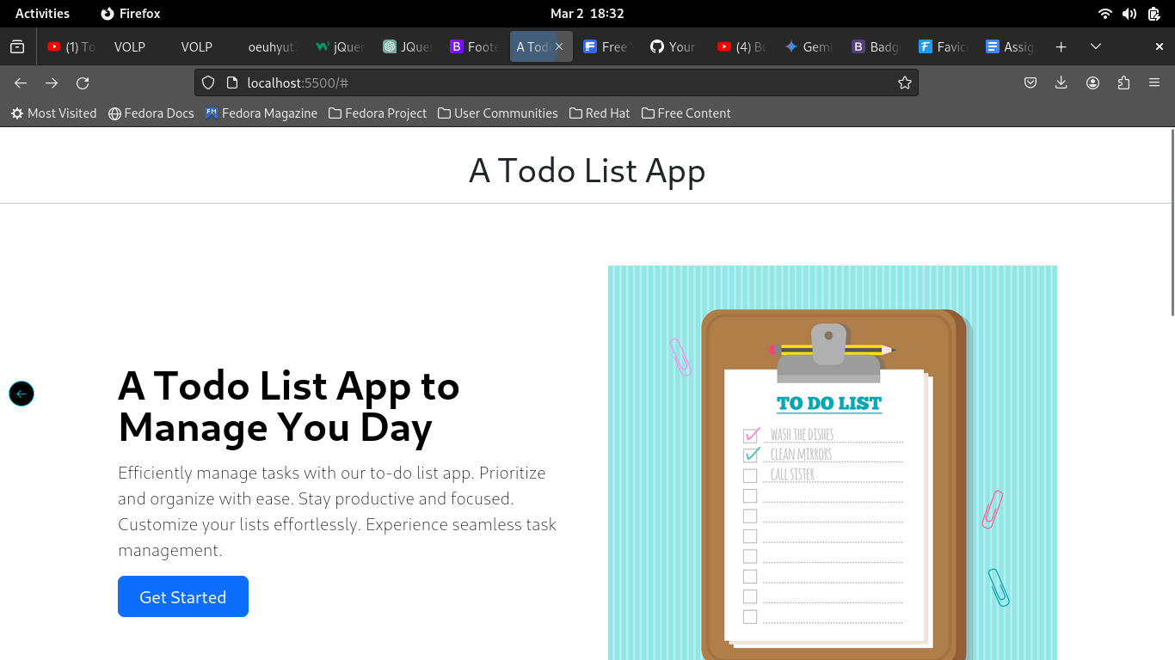

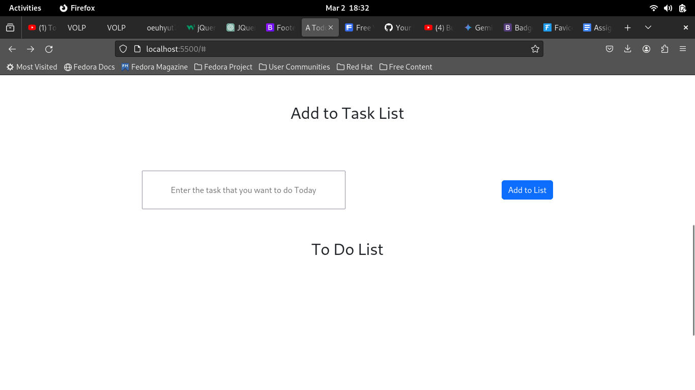

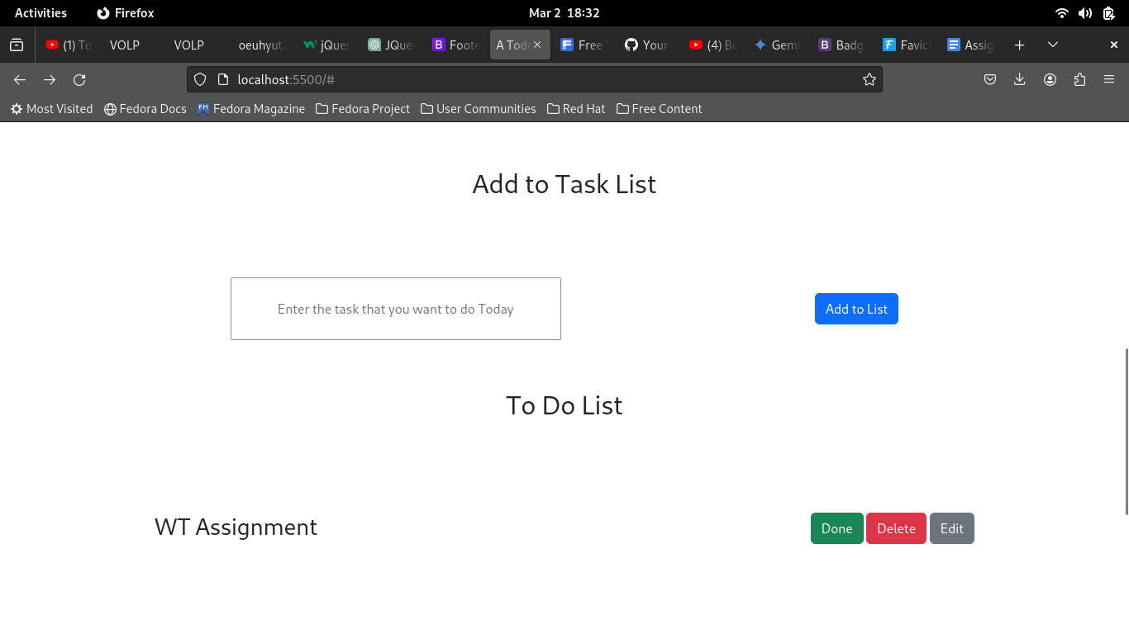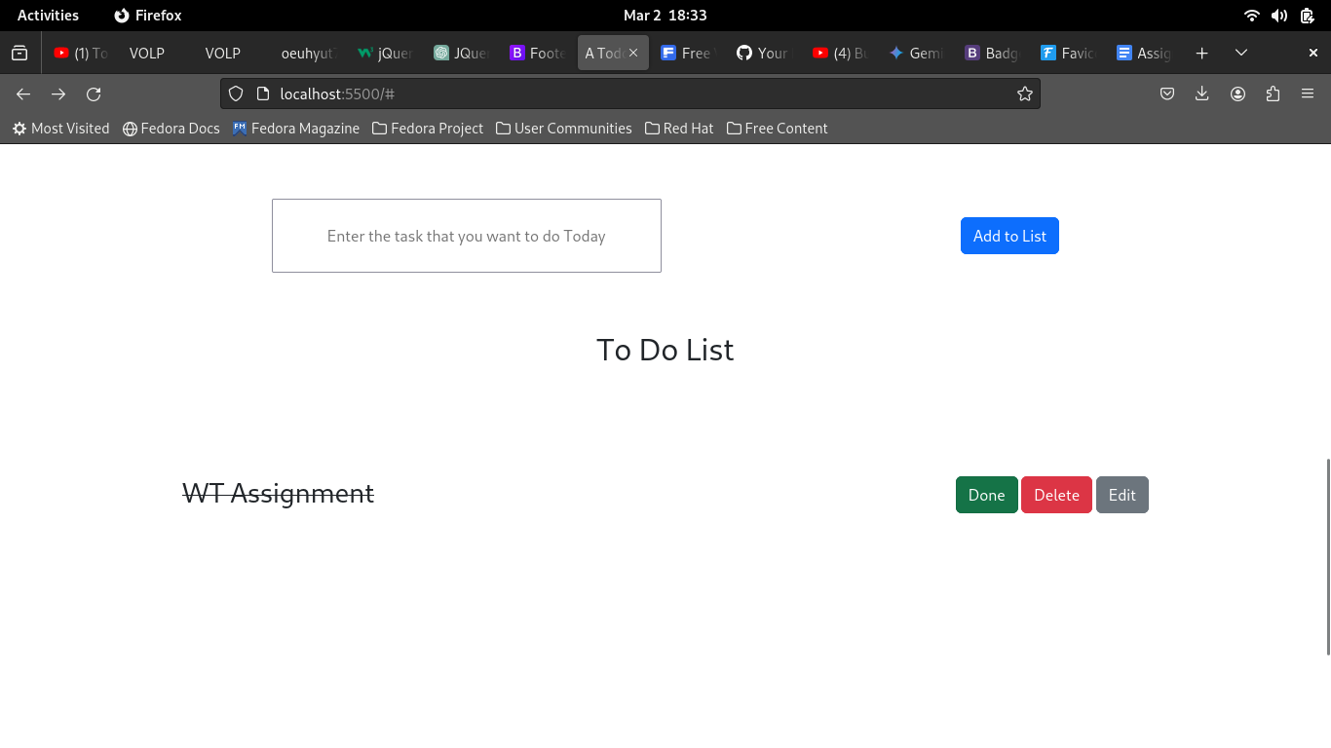

**Clicking on DONE Button**

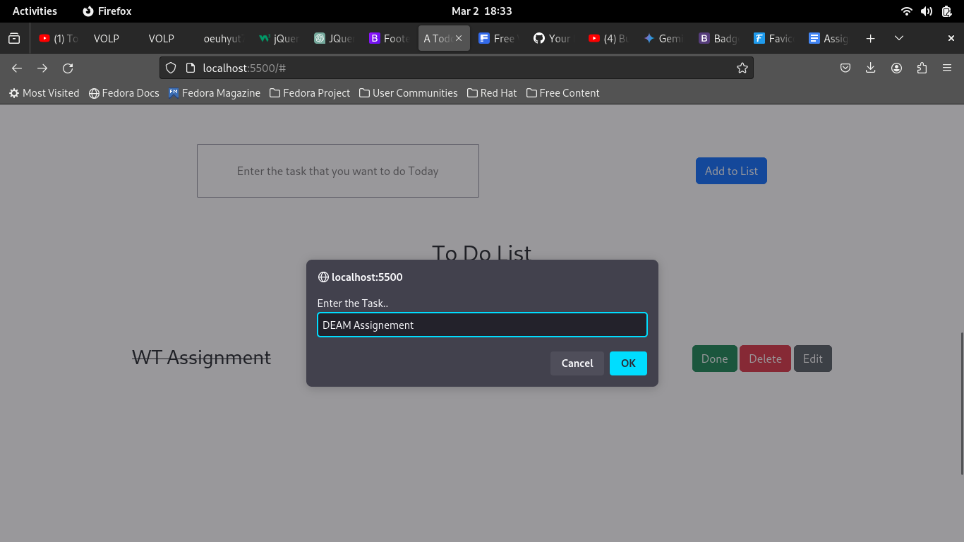

**Clicking On EDIT Button**

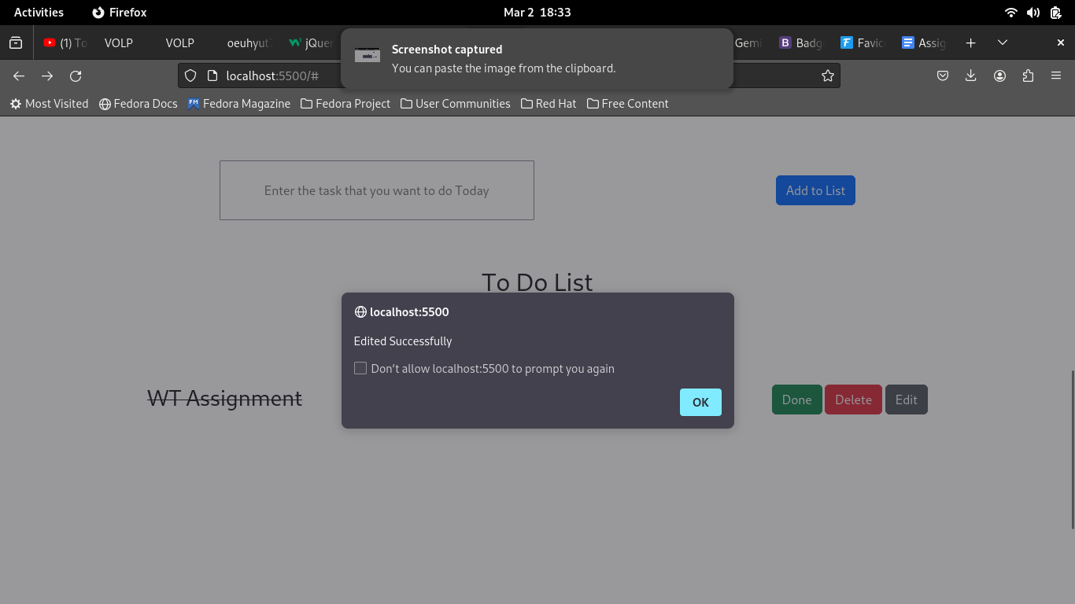

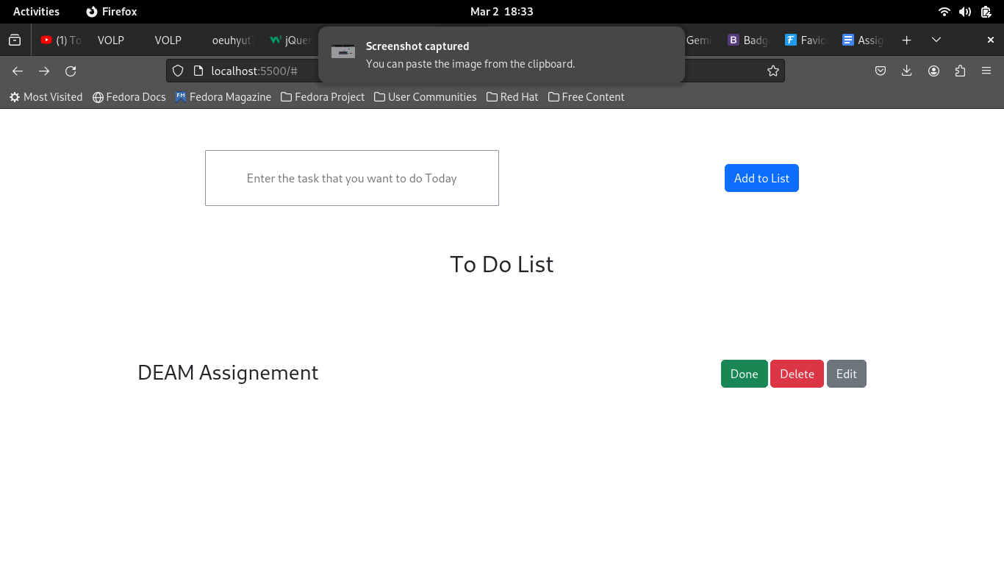

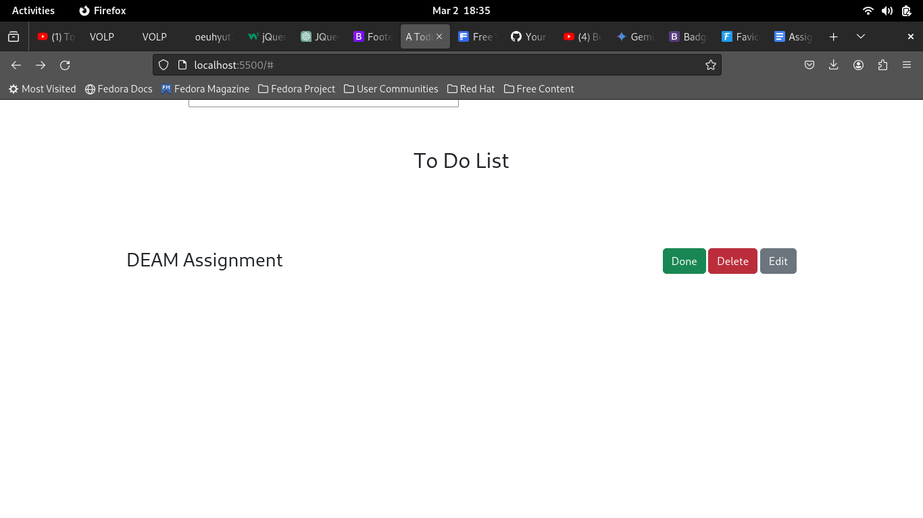

**On Clicking Delete Button**

